TITLE 2: GOVERNMENTAL ORGANIZATION
SUBTITLE E: MISCELLANEOUS STATE AGENCIES
CHAPTER XIV: ENVIRONMENTAL PROTECTION AGENCY

PART 1825
PUBLIC INFORMATION, RULEMAKING AND ORGANIZATION

SUBPART A: PUBLIC INFORMATION

Section
1825.10 Access to Information of the Illinois Environmental Protection Agency
1825.20 Procedures for Determining and Protecting Confidential Information

SUBPART B: RULEMAKING

Section
1825.30 Applicability
1825.40 Definitions
1825.50 Procedure
1825.60 Public Hearings

SUBPART C: ORGANIZATION

Section
1825.70 Applicability
1825.80 Definitions
1825.90 Agency Organization
1825.APPENDIX A Organization Chart of the Environmental Protection Agency State of Illinois Part One (Repealed)
1825.APPENDIX B Organization Chart of the Environmental Protection Agency State of Illinois Part Two (Repealed)
1825.ILLUSTRATION A Organization Chart of the Illinois Environmental Protection Agency

AUTHORITY: Implementing Section 5-15 of the Illinois Administrative Procedure Act [5 ILCS 100/5-15] and authorized by Section 4 of the Environmental Protection Act [415 ILCS 5/4].

SOURCE: Adopted at 8 Ill. Reg. 23202, effective November 30, 1984; amended at 34 Ill. Reg. 9019, effective June 22, 2010.

SUBPART A: PUBLIC INFORMATION

Section 1825.10 Access to Information of the Illinois Environmental Protection Agency

The Illinois Environmental Protection Agency’s (Agency) policy concerning public access to Agency information is contained in the Agency’s rules “Access to Public Records of the Illinois Environmental Protection Agency” (2 Ill. Adm. Code 1828).

(Source: Amended at 34 Ill. Reg. 9019, effective June 22, 2010)

Section 1825.20 Procedures for Determining and Protecting Confidential Information

The Agency’s policy concerning the determination and protection of confidential information is contained in “Access to Public Records of the Illinois Environmental Protection Agency” (2 Ill. Adm. Code 1828).

(Source: Amended at 34 Ill. Reg. 9019, effective June 22, 2010

SUBPART B: RULEMAKING

Section 1825.30 Applicability

This subpart applies to all divisions within the Illinois Environmental Protection Agency.

Section 1825.40 Definitions

Statutory definitions shall apply to terms in Agency rules, unless otherwise defined.

Section 1825.50 Procedure

a) Rules may be proposed by the Director or Agency’s divisions. Final adopted rules shall only be approved by the Director.

b) Any interested person may petition the Director to make, amend or repeal an Agency rule.

1) The petition shall be addressed to:

Director
Illinois Environmental Protection Agency
1021 North Grand Ave. East
PO Box 19276
Springfield, Illinois 62794-9276

2) The petition shall contain a clear statement of reasons for the proposed rule, amendment or repeal and the exact language of the suggested new rule or amendment.

c) The principal copy of the Agency’s adopted rules, which have been filed with the Secretary of State Administrative Code Unit (ACU) and stamped by the ACU with the date the rules were filed, shall be kept at the Agency’s Library at 1021 North Grand Ave. East, Springfield, Illinois; other stamped copies shall be kept at the Agency’s divisional regional offices, and shall be available for public review from 8:30 am to 4:30 pm during State working days.

d) In proposing and adopting rules the Agency shall follow the requirements of the Illinois Administrative Procedure Act [5 ILCS 100]; the rules of the Joint Committee on Administrative Rules (1 Ill. Adm. Code 220, 230 and 240); the Secretary of State's “Rulemaking Procedures” (1 Ill. Adm. Code 100), and the Secretary of State’s “Administrative Code Style Manual”.

(Source: Amended at 34 Ill. Reg. 9019, effective June 22, 2010)

Section 1825.60 Public Hearings

Public hearings required under Section 5-40(b)(5) of the Illinois Administrative Procedure Act [5 ILCS 100/5-40(b)(5)] shall be held in accordance with the Agency’s “Procedures for Informational and Quasi-Legislative Public Hearings” (35 Ill. Adm. Code 164).

(Source: Amended at 34 Ill. Reg. 9019, effective June 22, 2010)

SUBPART C: ORGANIZATION

Section 1825.70 Applicability

This Part applies to all divisions and sections within the Illinois Environmental Protection Agency.

Section 1825.80 Definitions

"Agency" means Illinois Environmental Protection Agency.

"Division" means a unit of the Agency, responsible for carrying out certain administrative duties, functions and policies and managed by a Divisional Manager.

Section 1825.90 Agency Organization

a) The organization and duties of the Agency staff are established by the Director, as provided by Section 4 of the Environmental Protection Act [415 ILCS 5/4].

b) The organization of the Agency is illustrated in the organization chart in Illustration A, or as hereafter amended.

(Source: Amended at 34 Ill. Reg. 9019, effective June 22, 2010

Section 1825.APPENDIX A Organization Chart of the Environmental Protection Agency State of Illinois Part One (Repealed)

(Source: Repealed at 34 Ill. Reg. 9019, effective June 22, 2010)

Section 1825.APPENDIX B Organization Chart Environmental Protection Agency State of Illinois Part-Two (Repealed)

(Source: Repealed at 34 Ill. Reg. 9019, effective June 22, 2010)

Section 1825.ILLUSTRATION A Organization Chart of the Illinois Environmental Protection Agency
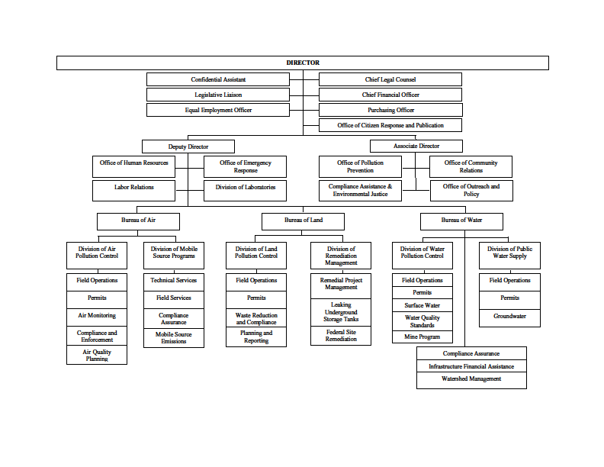
(Source: Added at 34 Ill. Reg. 9019, effective June 22, 2010)

